**Adding a New Bill of Material**

The inbound file is a comma-delimited file named xbom.csv and saved to the global\files directory.

The file layout is defined below with the length of each field in parenthesis.

**The bold fields are required.**

|  |  |  |  |
| --- | --- | --- | --- |
|  | Field Name | Length | Comments |
| 1 | **Parent part number** | 20 |  |
| 2 | **Child part number** | 20 |  |
| 3 | **Quantity** | +-8.6 | Qty of child part to make a single parent |
| 4 | Child part description | 60 | 1-30 go into BOM Engineering file’s description |
|  |  |  | 31-60 go into BOM Engineering file’s memo1 |
| 5 | Parent product line | 2 | Used when adding parent to inventory |
| 6 | Child sort code | 12 |  |
| 7 | Child drawing | 20 |  |
| 8 | Child tag | 6 |  |
| 9 | Child memo 1 | 30 | Added later to file layout and will override last 30 in #4 above |
| 10 | Child memo 2 | 30 |  |
| 11 | Parent description | 60 | 1-30 go into BOM Engineering file’s description and inventory master part description |
|  |  |  | 31-60 go into BOM Engineering file’s memo1 and inventory part additional description1 |
| 12 | Parent location code | 2 | Used to find inventory part and/or create a new inventory part |
|  |  |  | Used to create new BOM Engineering file record |
| 13 | Parent part revision | 3 |  |
| 14 | Parent unit of measure | 2 |  |
| 15 | Parent cost | +-8.4 |  |
| 16 | Parent source code | 1 | See valid codes below |
| 17 | Parent sort | 12 |  |
| 18 | Parent memo1 | 30 |  |
| 19 | Parent memo2 | 30 |  |
| 20 | Child location code | 2 |  |
| 21 | Child part revision | 3 |  |
| 22 | Child unit of measure | 2 |  |
| 23 | Child cost | +-8.4 |  |
| 24 | Child source code | 1 | See valid codes below |
| 25 | Child category code | 1 | See valid codes below |

|  |  |
| --- | --- |
| *Valid source codes are: | **Valid category codes are: |
| ▪  P = Purchase to Stock | ▪  blank = Normal |
| ▪  J = Purchase to Job | ▪  P = Phantom |
| ▪  M = Manufacture to Stock | ▪  X = Exclude |
| ▪  F = Manufacture to Job | ▪  1 = Is Setup |
| ▪  C = Consigned to Stock | ▪  R = Is Reference |

A couple of other notes for the upload:

* Will send the user a message if the bom exists and asks if they wish to delete and replace it.
* Will create inventory parts for the parent part only.
* Will create inventory cross reference for parent part only.
* Will update inventory part’s description for child parts found in inventory and part cross reference.
* Will allow duplicate line records.
* Will create router with material lines only.
* Will give a status and summary screen of records imported.
* Will pull source, UM, and cost from the inbound file. If empty on inbound file, the upload will pull from the inventory master. If not on the inventory master, the source will default to “F” for parents and “J” for child parts, unit of measure will default to “EA”, and cost will be zero.

The inbound xbom.csv file is shown below using only the first 6 fields, opened in Excel.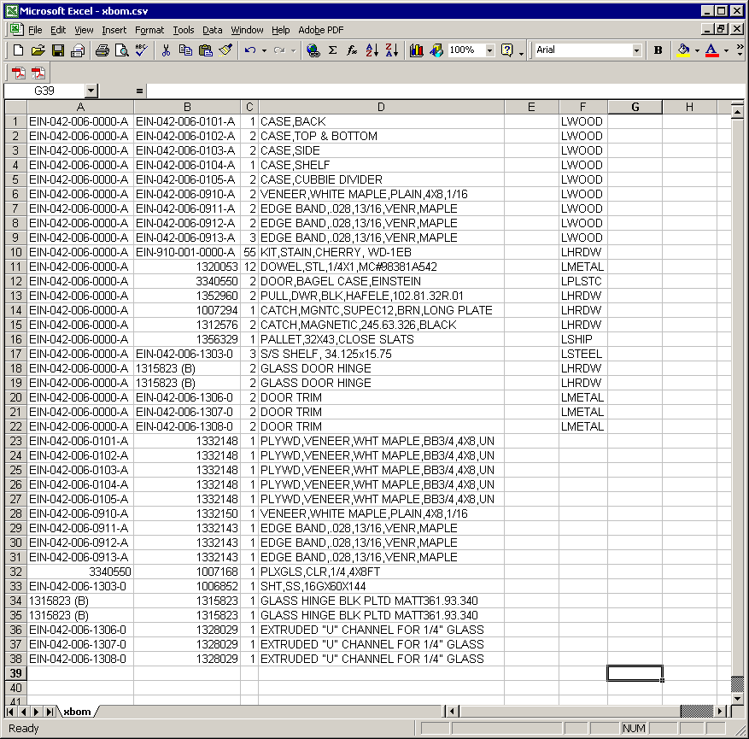

The inbound file xbom.csv is shown below, opened in Notepad.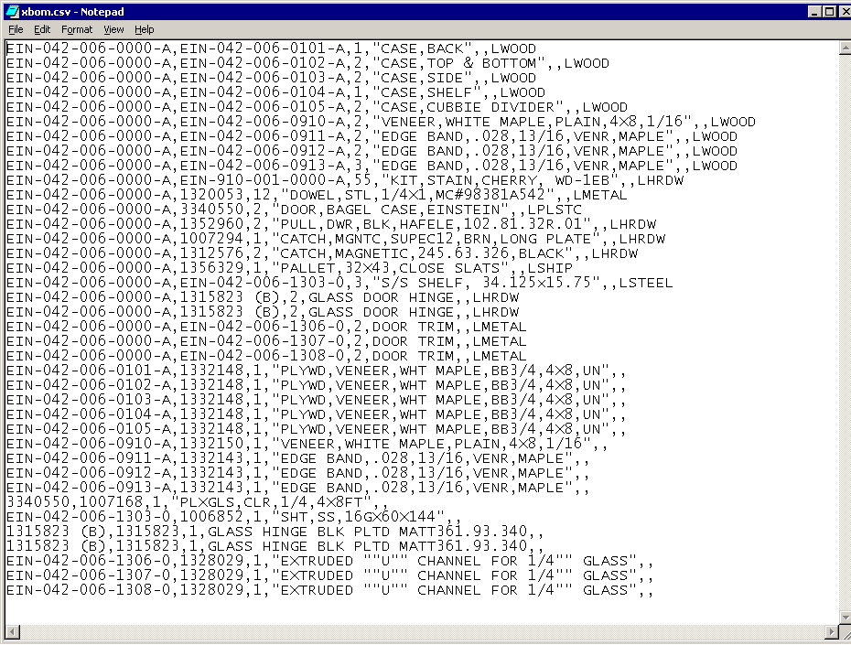

The xbom.csv file was in global\files before running the custom menu item highlighted below.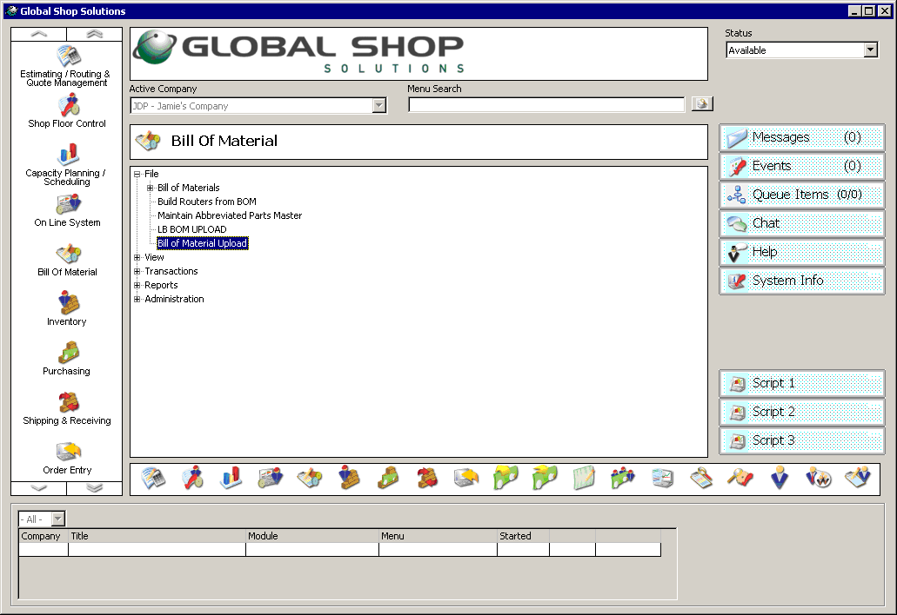

Below is the status message that appears during the import.

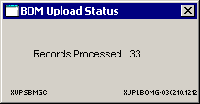

Below is the summary screen that appears after the import is finished.

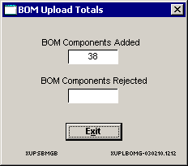

END OF IMPORT PROCESSING…

In Bill of Material > File > BOM > Open…

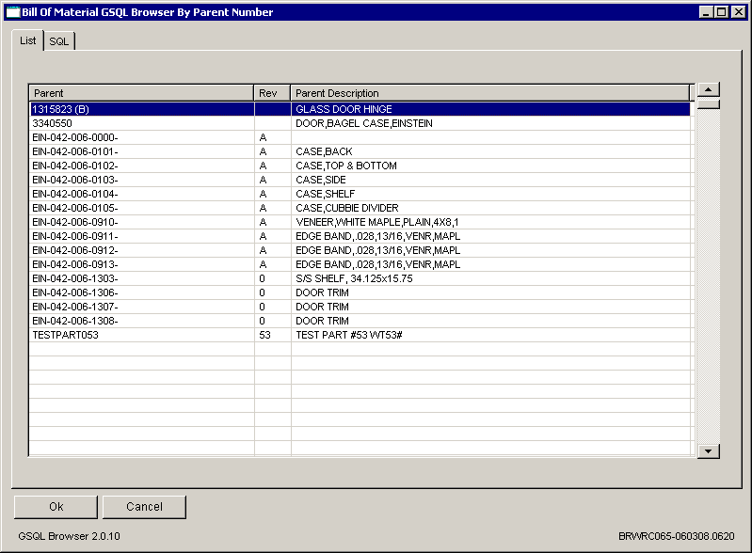

Selected the top level parent ending in 0000- rev A.

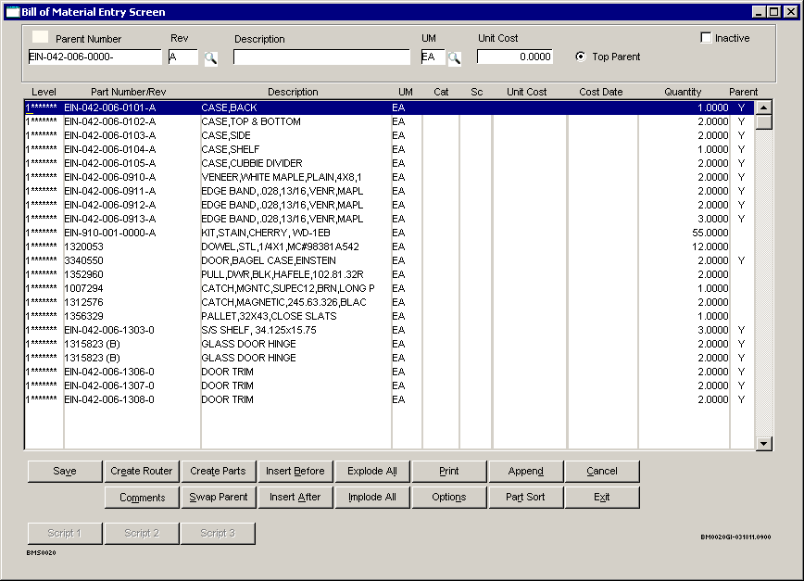

Selecting Explode All…

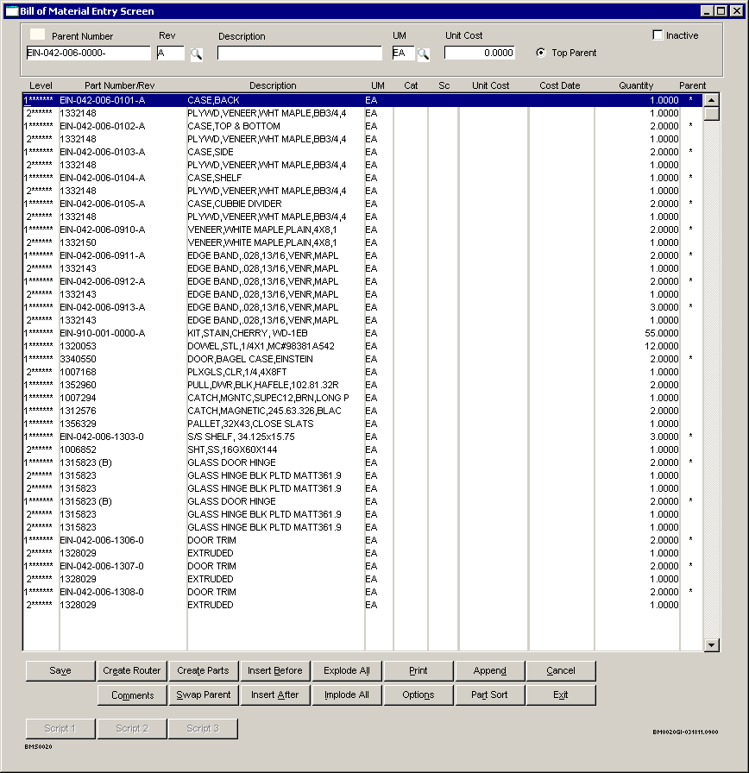

Selecting the very first detail line and Options to show the Sort Value from the inbound file…

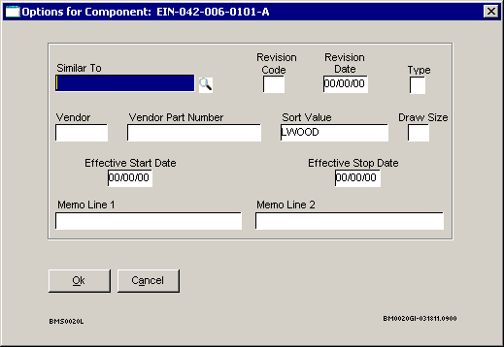

Double-clicking on the second line item (child to the first level parent) to show what happens when the description is more than 30 characters.

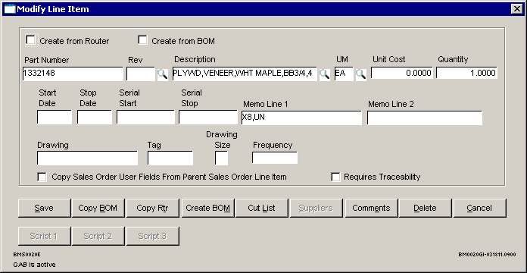

**Updating an Existing Bill of Material**

If you run the import for an existing bill of material, this message appears…

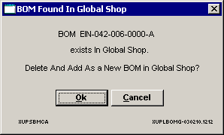

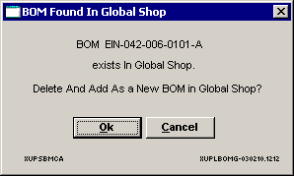

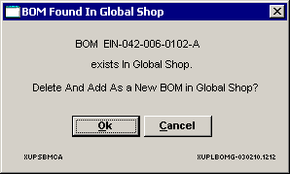

And so on for all the duplicated parents.

The status and summary screen will look the same as above.